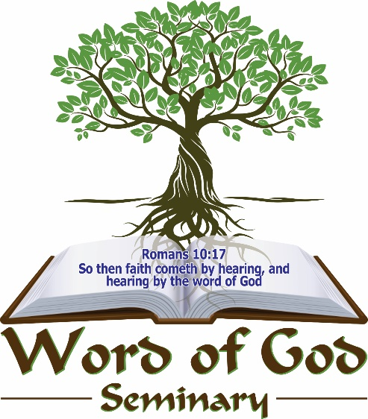

PROSPECTUS

A calling for the glory of GOD

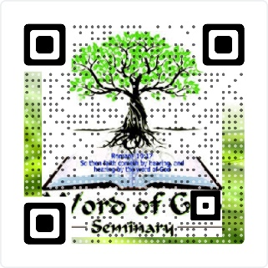

TABLE OF CONTENTS

Disclaimer 3
Programs 3
The Leadership 4
About Word of God Seminary 6
Vision 6
Mission 6
Accreditation 7
Time limits on programs 8
Life experience 8
General info 9
Recognition of Prior Learning (RPL) 9
Graduation 9
Financial information 10
Programs 11
Pastoral Course 11
Evangelism 11
Certificate in Ministry 11
Diploma in Ministry/Theology 12
Bachelor Degree in Ministry/Theology 12
Honors’ Degree in Ministry 13
Honors’ Degree in Theology 13
Ordination Program 14
Diploma in Prophetic Studies 14
Diploma in Counselling 15
Bachelor Degree in Counselling 15
Honors’ Degree in Counselling 16
Master’s Degrees in Ministry/Theology & Counselling 16
Doctorate Degrees in Divinity/Ministry/Theology/Counselling & Philosophy 17
Doctorate Degree Program 18
Honorary Doctorate Degree 16

DISCLAIMER

Although the information contained in this prospectus has been compiled as accurately as possible, Word of God Seminary accepts no responsibility for any errors or omissions. The prospectus will be effective as from January 01, 2025. Information reflected in this prospectus is accurate at the time of going to publication.
Course subject contents in the different categories can be changed and adjusted without prior notice.

Word of God Seminary

Equipping Ordinary People for Extra-Ordinary Ministry

PROGRAMS

WoGS Pastoral Course
WoGS Ordination Program (New)

WoGS Evangelism Course
Certificate in Ministry

Diploma in Ministry/Theology
Diploma in Counseling
Diploma in Prophetic Studies

Bachelor Degree in Ministry/Theology
Bachelor Degree in Counseling

Honor’s Degree Ministry
Honor’s Degree Theology
Honor’s Degree Counseling

Master’s Degree Ministry
Master’s Degree Theology
Master’s Degree Counseling

Honorary Doctor Degree were applicable
Doctor of Divinity (DD)
Doctor of Ministry (D.Min)
Doctor of Theology (D.Th)
Doctor of Counselor (DC)
Doctor of Philosophy (PhD)

The Leadership Team

Rector Vice-Rector & Registrar
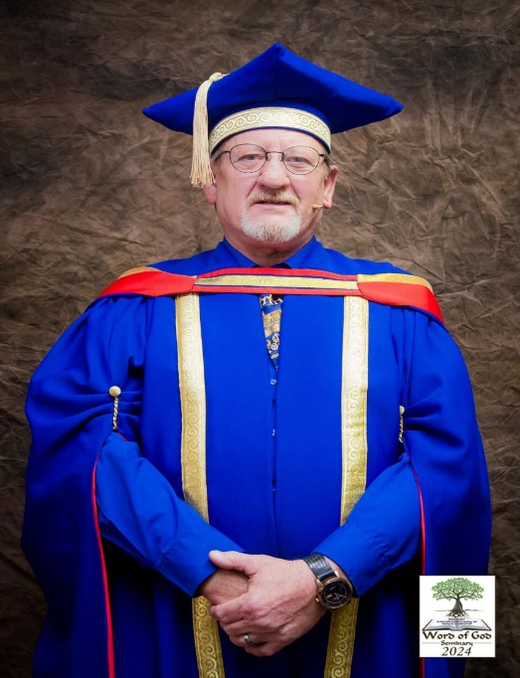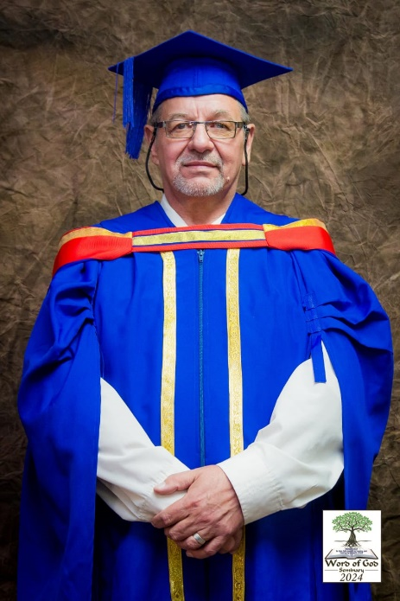
Prof. NM Nieuwoudt Asst.Prof. AW Burger
(DThM, Ph.D.) (DD, DThM, Dcouns & Ph.D.)

Dean & Research Media & Assistant to the Registrar
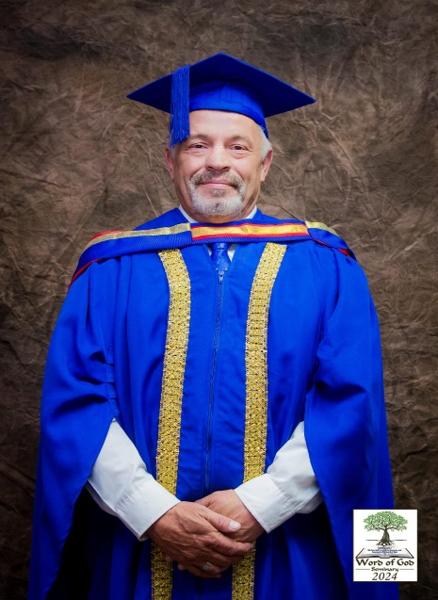
Dr. PF Booysen (DD, DMin & Ph.D.) Dr. Jill Burger-Howard (DCouns)

WoGS Ambassador

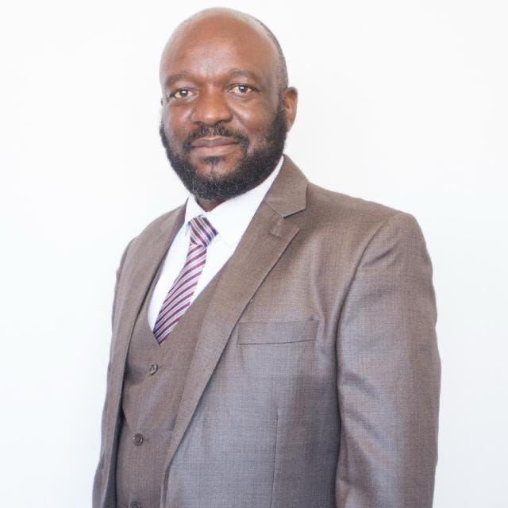

Rev Robert Thema (B.Th.)

Graduation 2025
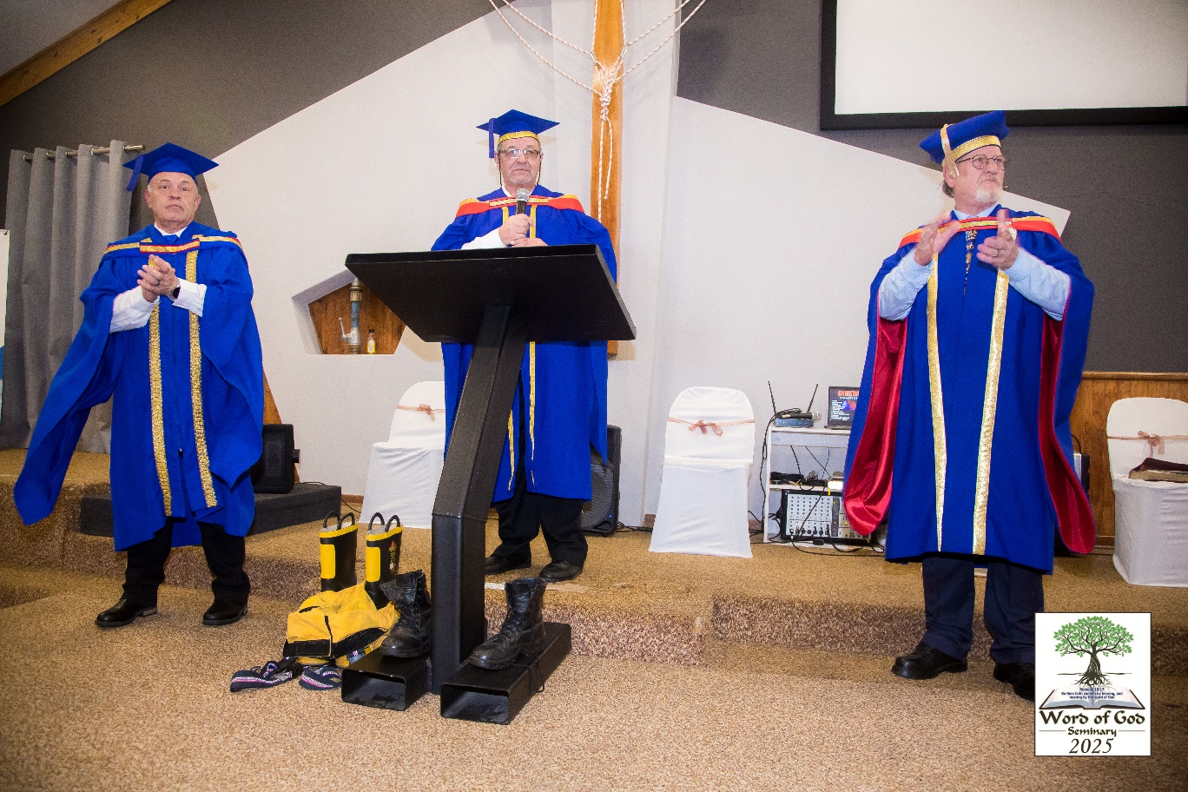

ABOUT WORD OF GOD SEMINARY

Word of God Seminary is a formal training institution that is registered as a NPC in South Africa
(Reg: 2021/952089/08.) The seminary has been started by four passionate well-experienced Christian leaders and academics with a vision to train God’s children.
This seminary was specifically established to train everybody who is hungry to learn more about the Word of God internationally.
The seminary is run by a board of directors and a competent management and operational team with many years of accumulated knowledge and experience and with a very good administrative infrastructure, and will provide skill orientated training to students through training presented in classrooms, distance learning and on an online basis.

VISION

We are committed to deliver value driven, theory, practical and personally transformative training to God’s children seeking knowledge of the Word of God. Our courses are specifically designed to meet all the ministry, theology and counseling related requirements of individuals with a vision to change society, through proclaiming the Gospel of the Lord.

MISSION

Our mission is to deliver the highest quality training to all students enrolled and believe that the teaching of sound knowledge, ethical and moral values will make a significant contribution to the sustainability of society.
An objective of WoGS is that a student learns, not about the Bible, but learns the Bible. The intent is that each student learns Biblical truths.
We are committed to removing the fear factor from the desire to earn a Biblical qualification. The Bible is our textbook and each course uses the Bible plus prescribed manuals for the various subjects.

ACCREDITATION, MOU’S AND PARTNERSHIP’S

International Accreditation
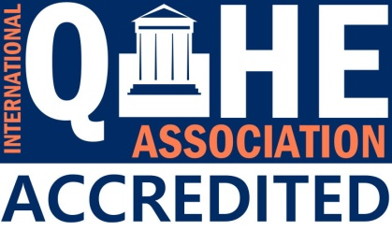
International Association for Quality Assurance in Pre-tertiary and Higher Education (QAHE), registration ID: 120562
11923 NE Sumner Street STE 737530
Portland, Oregon, 97220
USA
www.qahe.org
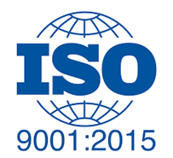 ISO 9001:2015 accreditation with: AQS Certification Services
www.aqscertifications.com - www.aqscertification.org.uk
QMS Certificate Number: 0909242

 MoU with “The Counselling Association of South Africa”.
www.counselling-sa.co.za

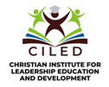 MoU with “Christian Institute for Leadership Education and Development”
16192 Coastal Highway, Lewes,
Delaware 19958, USA
https://www.thechristianinstitute.net/

 Partnership with Harvestime International Institute - https://harvestime.org/

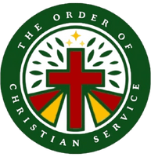 MoU with “Order of Christiaan Service” (OCS) – https:// https://orderofchristianservice.co.za/

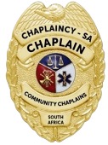 Partnership with “Chaplaincy –SA” – https://chaplancysa.co.za/

TIME LIMITS ON PROGRAMS

The following time limits are given for the following qualifications and note that the pass rate is 60% per subject and all subjects to be completed successfully. If a subject is required to be re-written only the pass rate will be recorded.

WoGS Pastoral Course | 4 Years Max depending on RPL
WoGS Ordination Program (New) | 1 Year
WoGS Evangelism Course | 1 Year
Certificate in Ministry | 1 Year
Diploma in Ministry/Theology | 1 Year
Diploma in Counselling | 1 Year
Diploma in Prophetic Studies. | 1 Year
Bachelor’s Degree in Ministry/Theology (Not Pastoral) | 2 Years Max
Bachelors in Counselling | 2 Years Max
Honors Degree in Ministry/Theology/Counselling | 1 Year
Master’s Degree in Ministry/Theology/Counselling | 2 Years Max
Doctorate Degree in Ministry/Theology/ Divinity/ Counselling and PhD | 2 Years Max per degree, with a gap year in between degrees.

LIFE EXPERIENCE

All degrees at Word of God Seminary are Earned Degrees. This is achieved by mandatory course work that must be completed.

Our courses are available to anyone who meets our enrolment requirements. Our courses require comprehensive study and self-discipline as the Seminary is an online and class based learning institution.

Bible School, College or Seminary transcripts do not always reflect real life experience therefore Word of God Seminary recognizes life experience that may have been gained through years of work that is ministry, theologically and counselling related.

Many people have served in ministry, theological and counselling positions and have gained a lot of knowledge and experience in their fields, but do not have a formal ministry, theological and counselling certificate or degree.
Life experience credits can give some of the recognition needed for this service in the work of the Lord and these acceptance of life experience credits helps potential students to accelerate their learning institution knowledge and enabling them to earn a fully accredited diplomas or degrees.

No Bible School, College or Seminary accolades, degrees can be awarded based purely upon life experience, and therefore life experience credit cannot be given for an entire degree but is limited to a maximum of 30 credit. Life experience which may include books authored, missionary trips, classes taught, outreach ministries, ministries within a church, etc., must be documented along with the years they occurred and submitted for evaluation.

GENERAL INFORMATION

* WoGS is a Non-Denominational Institution
* Students must be able to read, write and speak English to apply, however recognition of prior Learning (RPL) will apply during application.
* Note: All mentioned qualifications and post graduate studies done through “Word of God Seminary”
are a “Word Knowledge” qualification and not “Academic”.
- Course material contents are subject to change without prior notice.
- Course material can be obtained in hard copy or soft PDF copy, note that hard copy printing fees are not included in the course fee, although WoGS sponsor a % of the printing costs.
- WoGS have a Memorandum of Understanding with “The Counselling Association of South Africa” where WoGS counselling course subjects has been approved.
- Majority of the course material used by WoGS are from Harvestime Institute under their T&C’s
- Online examinations to be booked 48 hours with the registrar of WoGS in advance during office hours.
- Additional counselling technique course are available for counselling registered students at reduced cost through Vida Health & Wellness, training section of the Counselling Association of South Africa.
- NB: Students from outside of South Africa, note that South Africa time zone is applicable when you do your booking for on-line examinations.
RECOGNITION OF PRIOR LEARNING

Complete the application form and submit together with copies of the transcripts and relevant qualifications.
RPL costs upon approval are as follows:
Diploma Course = R500
Bachelor, Honors Course and Affiliated Satellite Schools = R750
All other Post Graduate Courses = R1000
*Note: RPL costs are non-refundable
GRADUATION

Word of God Seminary will have a graduation ceremony at the end of each year and regional graduation ceremonies throughout South Africa will be held if and when so required and approved by the Board of Directors.
Note that attendance is not compulsory but recommended.
Certificates, Diplomas and Degrees will be forwarded to students in soft and hard copy format once a year on completion of their studies, provided course and graduation fees has been paid up to date if they cannot attend the graduation ceremony.

Graduation costs will only be available later during each financial year and is therefore not included.

FINANCIAL INFORMATION

Pastoral Course (Subjects, practical & assignments) | Registration Fee R1500.00  R425.00 x 27 months – Total: R12950.00
Ordination Program (New) (mini thesis assignments & practical) | Cost on request
Evangelism Course (10 Subjects, and practical’s assignments) | Registration Fee R500.00  R313.00 x 10 months – Total: R3630.00
Certificate in Ministry (10 subjects & essay assignment) | Registration Fee R500.00  R313.00 x 10 months – Total: R3630.00
Diploma in Ministry/Theology (10 subjects, practical sermon & essay assignment) | Registration Fee R700.00  R425.00 per month – Total: R4950.00
Diploma in Counselling (10 subjects, practical & essay assignment) | Registration Fee R700.00  R425.00 x 10 months – Total: R4950.00
Diploma in Prophetic Studies (10 subjects and essay assignments) | Registration Fee R1000.00  R410.00 x 15 months - Total: R7150.00
Bachelor Degree in Ministry/Theology (15 subjects, practical sermon & essay assignments) (Not Pastoral) | Registration Fee R1000.00  R410.00 x 15 months - Total: R7150.00
Bachelor Degree in Counselling (11) subjects, practical evaluations & (5) six essay assignments) | Registration Fee R1000.00  R410.00 x 15 months - Total: R7150.00
Honors’ Degree in Ministry/Theology (10 subjects, practical sermon & essay assignment) | Registration Fee R700.00  R425.00 x 10 months - Total: R4950.00
Honors’ Degree in Counselling (10 subjects, practical evaluation & essay assignment) | Registration R1000.00  R615.00 X 10 months - Total: R7150.00
Master’s Degree in Ministry/Theology/Counselling, (Thesis and/or subjects) | Registration R2000.00  R735.00 X 10 months - Total: R9350.00
Doctorate Degree’s (Thesis, minimum one) | Registration R2000.00  R735.00 X 10 months - Total: R9350.00

Note: payments made from outside of South Africa could incur addissional “Foreign Exchange” banking fees.
Seminary Bank and Contact Details
Bank Details: Contact Details:
Capitec Business – Current Account Word of God Seminary NPC
Word of God Seminary NPC E-Mail: info@wogs.co.za
Acc No: 1051301602 E-Mail: marketing@wogs.co.za
BC: 470010 Web page: www.wogs.co.za
Swift: CABLZAJJ (foreign exchange)
*Note: All fees to be paid into the WoGS bank account using your student number and name.
“For affiliated satellite bible school, their name and registration number as reference.”

PROGRAMS

Note: That the course program and content can change without prior notice at the discretion of the Registrar after approval by the board

Pastoral Course

*Course syllabus will be communicated once the RPL process has been evaluated, RPL only applicable towards scholars with previous experience within the Ministry.

Note: The pastoral course and the Bachelor Degree in Ministry/Theology are two different courses.

Minimum requirement student to be able to read, write, communicate in English
Evangelism
Code | Name of Course | Credits
CT/1 | Old Testament | 2
CT/2 | New Testament | 2
CT/5 | Biblical Management Principles | 2
DT/2 | Methodologies of Multiplication | 2
DT/3 | Mobilization Methodologies | 2
DT/4 | Spiritual Harvest | 2
DT/6 | Knowing God's voice | 2
DT/8 | Evangelism | 2
WC/4/D | Communication & Conflict | 2
Assignments | Practical evaluations | 2
 | Theoretical assignments | 2
 | Total credits | 22
 | *Minimum of 10 Subjects + assignments

Minimum requirement student to be able to read, write, communicate in English
Certificate in Ministry
Code | Name of Course | Credits
CT/1 | Old Testament | 2
CT/2 | New Testament | 2
CT/3 | Trinity | 2
CT/4 | Armor of God | 2
CT/5 | Biblical Management Principles | 2
CT/6 | Creative Bible Study | 2
CT/7 | Kingdom Living | 2
CT/8 | Teaching Tactics | 2
CT/9 | Foundation of Faith | 2
CT/10 | Prayer 101 + Assignment | 4
 | Total credits | 22
 | *Minimum of 10 Subjects + assignment

Minimum requirement Certificate in Ministry/Theology

Diploma in Ministry/Theology
Code | Name of Course | Credits
DT/1 | Holy Spirit | 2
DT/2 | Methodologies of Multiplication | 2
DT/3 | Mobilization Methodologies | 2
DT/4 | Spiritual Harvest | 2
DT/5 | Homiletics | 2
DT/6 | Knowing God's voice | 2
DT/7 | Hermeneutics - 1 | 2
DT/8 | Evangelism | 3
DT/9 | Walking in the Spirit 1 + Assignment | 4
DT/10 | Possessing the promises (claiming the Abrahamic Covenant) | 2
Assignment  Practical | Practical Sermon 15 Min sermon. | 2
Assignment  Theoretical. | Theoretical assignment - A minimum of 8000 words, Calibri 12. | 3
 | Total credits | 28
 | *Minimum of 10 Subjects + assignments

Minimum requirement Diploma in Ministry/Theology
Bachelor’s Degree in Ministry/Theology
Code | Name of Course | Credits
BT/1 | Environmental Analysis | 4
BT/2 | Management by Objectives | 4
BT/3 | Women Biblical Profile | 4
BT/4 | Power Principle | 4
BT/5 | Spiritual Warfare | 4
BT/6 | Battle of the Body | 4
BT/7 | Biblical World View | 4
BT/8 | Breaking Poverty Bonds | 4
BT/9 | Healing | 4
BT/10 | Shattering the shackles of shame | 4
BT/11 | Hermeneutics - 2 | 4
BT/12 | Praise and Worship | 4
BT/14 | Prophetic Training | 4
BT/15 | Understanding the Anointing | 4
AD/4 | Biblical Meditation | 4
Practical | Sermon/Teaching 30 Min | 4
Assignment Min 30 000 words Calibri 12 | Assignment topic to be allocated to individual students. | 10
 | Total credits | 74
 | *Minimum of 15 Subjects, practical & assignments
Minimum requirement Bachelor’s Degree in Ministry

Honor’s Degree - Ministry
Code | Name of Course | Credits
HT/1 | The Church & Church History + Assignments | 4
HT/2 | Successful Christian Leadership | 4
HT/3 | The nine gifts of the Spirit | 4
HT/4 | Understanding Biblical numbers | 4
HT/5 | Cults & Deliverance + Assignments | 4
HT/6 | Kingdom of Heaven | 4
HT/7 | The image and likeness of God V/S the Antichrist | 4
HT/8 | Intercessory Prayer | 4
AD/9 | Biblical Strategist for Confronting Crisis | 4
AD/24 | Temple and tithing | 4
Assignments | Practical Sermon 45 Min | 2
Min 30 000 words  Calibri 12 assignment | Topic to be allocated to individual students. | 3
Total credits |  | 45
Minimum of 10 Subjects, practical and assignments

Minimum requirement Bachelor’s Degree in Theology

Honor’s Degree - Theology
Code | Name of Course | Credits
HT/1 | The Church & Church History + Assignment | 4
HT/5 | Cults & Deliverance + Assignment | 4
HT/9 | Basic Christian Doctrines | 4
HT/10 | Ministering in the Prophetic | 4
HT/11 | Ministering Spirits the Angels of God | 4
HT/12 | Biblical Prophecy | 4
HT/13 | Biblical Theology | 4
AD/5 | Biblical EQ
AD/11 | Defending the spirit of prophecy | 4
AD/40 | Passing On Mantle of the Anointing | 4
Assignments | Practical – Word Teaching 45 Min | 2
Min 30 000 words  Calibri 12 | Topic to be allocated to individual students | 3
Total credits |  | 45
*Minimum of 10 Subjects, practical and assignments

Minimum requirement Bachelor’s Degree in Ministry or Theology
Ordination Program
Code | Name of Course | Credits
ODP/1-14 | Subjects, Mini thesis assignments & practical | 2 each
Total credits |  | 28

Minimum requirement Certificate in Ministry or equaling

Diploma in Prophetic Studies
Code | Name of Course | Credits
HT/10 | Ministering in the Prophetic | 2
AD/4 | Biblical Meditation | 2
HT/8 | Intercessory Prayer | 2
CT/6 | Creative Bible Study Methods | 2
HT/11 | Ministering Spirits – the Angels of God | 2
BT/5 | Spiritual Strategies: Spiritual Warfare | 2
HT/12 | Biblical Prophecy | 2
AD/11 | Defending the spirit of prophecy | 2
AD/40 | Passing On Mantle of the Anointing | 2
Assignment minimum of 10 000 words, Calibri 12 | Prophets in the Bible – Old Testament. Seek answers to these questions.  1. To whom did the prophet minister?  2. What was the purpose of the prophecy?  3. What was the response of the people to whom he/she ministered?  4. How did the prophet receive the prophetic word? (Through visions, dreams, trances, angels, hearing God’s voice, etc.)?  5. How did the prophet deliver the prophetic word? (Verbally, through song, acted out, written, etc.) | 4
Assignment minimum of 5000 words, Calibri 12 | Prophets in the Bible – New Testament. Seek answers to these questions.  1. To whom did the prophet minister?  2. What was the purpose of the prophecy?  3. What was the response of the people to whom he/she ministered?  4. How did the prophet receive the prophetic word? (Through visions, dreams, trances, angels, hearing God’s voice, etc.)?  5. How did the prophet deliver the prophetic word? (Verbally, through song, acted out, written, etc.) | 3
Assignment minimum of 5000 words, Calibri 12 | Biblical examples of: Prophetic oracles, exhortations, prayers, songs, visions, actions and personal prophecies. | 3
Total credits |  | 28
Minimum of 10 Subjects & 3 assignments

* Minimum requirement Certificate in Ministry or equaling Registration with the South Africa Counselling Association.

Diploma in Counselling
Code | Name of Course | Credits
WC/1/D | Basic Counselling: Practical Management | 4
WC/2/D | Basic Counselling Background | 4
WC/3/D | Altar counsellors guide | 4
WC/4/D | Communication & Conflict | 4
WC/5/D | Practical Christian Counselling | 4
WC/6/D | Pre-Marriage Counselling | 4
WC/7/D | Solution focus faith | 4
WC/8/D | The Spiritual Continum | 4
DT/1 | Holy Spirit | 4
DT/6 | Knowing God's voice | 4
Assignments  Practical & Theoretical. | Theoretical assignment - A minimum of 8000 words, Calibri 12 and Practical counseling evaluation | 4
 | Total credits | 44
 | *Minimum of 10 Subjects + Practical & Theoretical assignments

*Minimum requirement Diploma in Counselling or equaling Registration with the South Africa Counselling Association.

Bachelor’s Degree in Counselling
Code | Name of Course | Credits
WC/9/BT | Specialised Counselling: Anger Management | 4
WC/10/BT | Counselling Recipes | 4
WC/11/BT | Boundaries | 4
WC/12/BT | Christian Counselling | 4
WC/13/BT | Sex, God and Marriage | 4
WC/14/BT | How to assist the client to identify and cope with life’s pitfalls | 6
BT/8 | Breaking Poverty Bonds | 4
BT/10 | Shattering the shackles of shame | 4
BT/15 | Understanding the Anointing | 4
ADC/1 | Narcissistic borderline couples | 4
AD/30 | The Tongue – a creative force | 4
Practical | Practical Counselling evaluation. | 4
Assignments Theoretical. | Six (6) theoretical essay topics of a minimum of 20 0000 words each, Calibri 12 topic to be allocated by the Registrar of WoGS | 24
 | Total credits | 74
 | *Minimum of 11 Subjects, Practical and Theoretical Assignments

*Minimum requirement Bachelor’s Degree in Counselling or equaling Registration with the South Africa Counselling Association

Honor’s Degree Counselling
Code | Name of Course |  | Credits
HT/5 | Cults + Deliverance + Assignment |  | 4
WC/15/HT | Christian Marriage & Family Life |  | 4
WC/16/HT | The Mole: Healing After Sexual Abuse |  | 4
WC/17/HT | A Challenge to work with children |  | 4
WC/18/HT | Traumatology - Trauma Theory & Symptoms |  | 4
WC/19/HT | Traumatology - PTSD |  | 4
WC/20/HT | Traumatology - Debriefing |  | 4
WC/21/HT | Jail and Prison Ministry | 4
ADC/7 | Understanding mental illness | 4
ADC/9 | Engaging Resistant Children in Therapy | 4
Practical | Practical Counselling evaluation. |  | 2
Assignment  Theoretical | One (1) or more practical evaluation and assignment  Topics to be allocated to individual students by the Registrar of WoGS. Minimum of 30 000 words  Calibri 12 |  | 3
Total credits |  | 45
*Minimum of 10 Subjects + Practical & Theoretical Assignments

*Minimum requirement Honor’s Degree in Ministry/Theology/ Counselling Registration with the South Africa Counselling Association (Counselling only).

Master’s Degree
Code | Course | Credits
MM | Ministry Thesis | 50
MTh | Theology Thesis | 50
MWC | Counseling Thesis | 50

*Note: Motivational Report for Dissertation/Thesis paper Master’s Degree with three (3) topics is required followed by a minimum of 50 000 words, Calibri 12, dissertation/thesis paper, on the topic approved.

*Minimum requirement Master’s Degree in Ministry/Theology/Counselling Registration with the South Africa Counselling Association (Counselling only).

Doctorate Degrees
Code | Course | Credits
DD | Divinity | 48
D.Min | Ministry Thesis | 48
D.Th | Theology Thesis | 48
DoC | Counseling | 48
Ph.D. | Philosophy Thesis (Require min two (2) Doctoral Degrees) | 36

*Note: Motivational Report for Dissertation/Thesis paper Doctoral Degree with three (3) topics is required, followed by a 65 000 word, Calibri 12, dissertation/thesis paper, on the topic approved.

Doctorate Degree Program

A prospective doctorate student must have a Master’s Degree from any acceptable accredited institution, or complete a WoGS Master’s Degree program or the equivalent prescribed by the Board of Directors, to be eligible to enter this course.

Completed studies from any other institute will be accepted, based on RPL – Recognition Prior to Learning will be evaluated on application.

Prospective Doctorate students must provide three (3) topics of his/her own choice, which might include a preferred field he/she want to specialize in. WoGS will decide if one or more pre-scribed topic will be required.

The following doctorate degrees are available and can be done through WoGS:

- Honorary Doctorate (DH)
- Doctor of Divinity (DD)
- Doctorate of Counseling (DCouns)
- Doctorate of Ministry (D. Min)
- Doctorate of Theology (DTh)
- Doctorate of Philosophy (PhD)
Above are the outline of the prescribed Doctorate degree levels, whereas the minimum criteria to be eligible to be taken in consideration for a possible professorate appointment, will be at least two (2) doctorate degrees, (excluding an Honorary Doctorate Degree), where after a PhD degree can be obtained.

HONORARY DOCTORATE DEGREE

The Honorary Doctorate Degree (DH) is mainly to give recognition to Christian leaders for their faithful service to the Lord.

This Degree is awarded to distinguished individuals who have achieved outstanding results in ministry, who have served the body of Christ faithfully for many years and demonstrated outstanding leadership skills and character traits.

Candidates are challenged to develop their ministerial skills to refine and articulate a Biblical theology of ministry while in a setting of ministry. The degree is ideal for those who serve the church in congregational/ pulpit ministries, Para church organizations, mission agencies, and any other vocational ministry setting where advanced leadership skills and training would make a difference.

Life experience credits may include books authored, missionary trips, classes taught, outreach ministries, ministries within a church, etc., which is limited to a maximum of Thirty (30) credit hours. This life experience must be documented along with the years they occurred and submitted for evaluation.

Word of God Seminary recognizes and honours individuals of extraordinary achievement in the following, which might include:

- performs remarkable exploits in the Kingdom that reflect unusual devotion to Christ
- possesses a history of faithful service to local churches and other ministry vocations that have positively influenced communities
- demonstrates outstanding wisdom and command of Scripture knowledge and research
- has a good reputation in the Body of Christ as well as the Christian community?
- has a servant heart
- shows superior leadership abilities and achievements
- is of exemplary character and works to promote the common good of humankind
- develops course work and authors books
- seen as a father figure and is a good example to younger leaders

The Honorary Doctorate Degree is not automatically awarded. Potential recipients must first be nominated.
We believe that successful nominees will be able to increase their ability to influence people for Christ.

